Indiana Cancer Registrars Association

Policy and Procedure

Office: PRESIDENT

Written by: Mindy Burch, CTR

Date of Initial Approval: October 1993

Last Revision by: Claudia Jenkins, CTR

Revision Dates: 10/1998, 10/2001, 11/2005, 1/2012, 10/2017

Current Review Date: 10/2017

Serve on Committee: Awards Committee: President and two ICRA members – Excluding the Board of Directors, and ex-officio to all committee, tack force and liaison positions.

Term of Office: One (1) year term

Required Reports: Three or more reports to the Board, The Indiana Abstract, email messages, Web site, and the Annual Report to the membership.
POLICIES:
- The president shall have the responsibility of all activities of the association and receives from the membership the authority to program the activities to accomplish the objectives of the association while complying with the bylaws.
- The president shall preside at all meetings.
- The president shall appoint all standing committee chairperson, liaison and task force chairperson positions.
- The president shall delegate responsibility for any programs or activities outside the realm of a standing committee.
- The president shall serve as Past President/Nomination chairperson at the conclusion of his/her term of office.

PROCEDURES:
- Term of Office
  - The term of office begins at the end of the Annual Business meeting and through the following Annual Business meeting.
- Responsibilities:
  - Review, coordinate and direct the activities of the Board of Directors following the Indiana Cancer Registrars Association (ICRA) Bylaws and Code of Ethics.
  - Develop any new activities that will aid and enhance the growth of the ICRA, assign the appropriate chairpersons, task force and liaison or coordinate to fulfill these activities.
- Communication with members and Board of Directors:
  - Work closely with the Vice President and President-Elect, keeping them abreast of all activities of the association. Copy the President-Elect and VP on all pertinent correspondence.
  - Alert the Board of Directors when you will not be available for instance on vacation of away from the office for a period of time. The Vice President will assume all activities during the absence of the president.
  - Communication with the Executive Committee and the Board of Directors is a very important component of the success of the association. When possible communicate in writing (email or stale mail) between board meetings.
  - A President’s message is required for the Web site and each issue of The Indiana Abstract.
  - Send a welcome to ICRA email to all new members.
  - Periodic email messages to the membership enhance the communication between the members and the President.
- Oversee the Annual Business meeting, Recognition and Installation Ceremony and the Annual Fall Conference.
  - Reply to any and all correspondence to the President.
- Coordinate and Preside all Board of Directors Meetings:
  - At least three meetings should be scheduled annually.
  - A call for meeting agenda items is first requested from the board at least one month prior to the scheduled meeting. A formal announcement of the board meeting will follow once the agenda has been finalized by the President. The announcement of the meeting will include: the final agenda, date and directions to the meeting, any special information required to be reviewed prior to the meeting, past minutes, board report form and reimbursement form. The secretary is responsible for the distribution of the meeting information, but the president is responsible for the final version of the meeting agenda and must be approved prior to distribution to the board. See Appendix A – Meeting announcement, see Appendix B – Board meeting agenda example, see Appendix C – Board worksheet form example.
  - A “Task List” is generated by the secretary during the meeting to organize the many responsibilities of the board members and monitor the accomplishments of the tasks assigned at each meeting. See Appendix D – for a “Task List” example.
  - It is the responsibility of the president to select the board meeting locations and arrange for lunch. This expense should be budgeted during the first board meeting.
- Approve Annual Board of Directors Budget:
  - Prior to the first board meeting the president will request from the board a budget to be submitted during the first board meeting. On the board worksheet form there is adequate space to document the anticipated expense for each board activity. The President will approve or disapprove all submitted budgets during the first board meeting. See Appendix C – Board worksheet form example with budget submission related to board position activity. This worksheet form may also be used as a board report form. Other board report formats are acceptable.
- Produce an Annual Report to the Membership:
  - Coordinate and publish an Annual Report to the membership to be distributed at the Fall Conference and also on the Web site. This expense should be budgeted during the first board meeting.
  - Request a standard report from each board member at least one month prior to the Annual Business meeting. See Appendix E – 2005 Annual Report Table of Contents.
    - At a minimum the Annual Report should include:
      - Business Meeting Agenda and Recognition and Installation Ceremony Agenda
      - Prior ICRA Annual Business meeting minutes
      - Fiscal report of the Treasurer
      - Presidents report and report from each member of the board
      - Bylaw amendment
  - For those members not able to attend the Annual Business meeting, send an email message notifying them when the Annual Report is available on the ICRA Website.
- Distinguished Member Award:
  - This award is nominated by the members if ICRA. This expense should be budgeted during the first board meeting.
    - The president chooses a committee of at least two from the membership. Board members, except the president, are exempt form serving on this committee.
    - The president prepares and distributes the call for nominations. See Appendix F – Call for Distinguished Member nominations. This message can be sent via the ICRA email account. For those members without email a special mailing can be created and distributed via US Mail.
    - Nomination letters are copied by the chairperson and sent to the committee members for review and evaluation.
    - The committee is directed to review and evaluate the nominations following the Awards Committee policy and procedures and choose a recipient of the award. The president is not involved with the decision of the recipient of the award.
    - The recipient is announced to the President
    - The president purchases a plaque or gift for the recipient.
    - A letter to all nominees and a copy of the nomination letter will be mailed or hand delivered during the Recognition and Installation Ceremony during the Fall Conference. The cover letter to accompany the nomination letters is written by the President. See Appendix G – Congratulation Letter to Nominee.
    - During the Awards Ceremony the Committee members will read the recipients nomination letter and present the award to the Distinguished Member Recipient. See Appendix H – Plaque for Distinguished Member Award.
- Presidential Award:
  - The president evaluates ICRA members and the Board of Directors and may decide if there is a deserving member of this award. This award is given to persons who show dedication and enthusiasm to the association. This expense should be budgeted during the first board meeting.
  - The president purchases a plaque or gift for the recipient(s) and presents the award during the Recognition and Installation Ceremony at the Fall Conference. See Appendix I – Plaque for Presidential Award.
- Conduct the Annual Business Meeting:
  - Prepare agenda (See Appendix J – Agenda)
  - Distribute the Annual Report
  - Encourage Board of Directors to report during the meeting
  - Address any new business
- Conduct the Recognition and Installation Ceremony
  - Prepare agenda (See Appendix K – Agenda)
  - Express your appreciation through certificates/gifts.
  - Recognize new CTR’s and present CTR pins.
  - Distinguished Member Award announced
  - Presidential Award announced
  - Farewell massage from the president to the membership
  - Pass the gavel to the new incoming president.
- Policy & Procedures
  - Review and revise the policy & procedures annually at the conclusion of this term.
- Tax Exempt Status
  - Use ICRA tax ID number to avoid sales tax on purchases for ICRA.
Appendix A
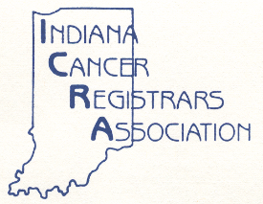

Indiana Cancer Registrars Association
(ICRA)
Board of Directors Members

MEMORANDUM

TO: 2012 ICRA Board Members

FROM: Cassie Nobbe, CTR Secretary
Sherry Dowling, CTR President

DATE: January 18, 2012

SUBJECT: January ICRA Board of Directors Meeting

Attachments: Agenda
September 9, 2011 Minutes
Transitional Meeting Minutes
2011 Annual Business Meeting Minutes
Reimbursement Form
Meeting Room Location Map

The Board of Directors Meeting for the Indiana Cancer Registrars Association has been rescheduled for Friday, January 27th starting at 9:30 AM at the St. Vincent Hospital Campus in the basement of the Orthopedic Center in Conference Room INDY-Ortho 4.
We will be taking care of the banking changes for ICRA AFTER the meeting.

The president will be providing lunch it this meeting. If you have special dietary needs please let her know as soon as possible.

If unable to attend, please contact Cassie at 812-932-4673 ext. 3120 or via e-mail at CASSANDRA.NOBBE@mmch.org or Sherry at (812) 522-0475 or via e-mail at sdowling@schneckmed.org prior to the meeting date.

Thanks,

Cassie Nobbe, CTR
2012 ICRA Secretary
Appendix B
INDIANA CANCER REGISTRARS ASSOCIATION
BOARD OF DIRECTORS (BOD) MEETING
JANUARY 13, 2012 - Rescheduled JANUARY 27, 2012
9:30a.m. - 3:30p.m. (EST)
St. Vincent Hospital, Orthopedic Center Basement, CR -Ortho 4
86th Street, Indianapolis, IN

A G E N D A

I. Meeting Called to Order (Sherry Dowling)
1. Introductions
2. Review attendance, quorum (Judi Reininga)
3. Review meeting agenda - Approve any additions

II. Review/Approve Minutes of Previous Meetings
1. September 2011 - BOD Meeting
2. November 2011 - Annual Business Meeting
(To be Included in 2012 Annual Business Meeting for Approval)
3. November 2011 - Transitional Meeting
4. November 2011 - Recognition & Installation Ceremony

III. Treasurer's Financial Report (Lori Carroll)
1. Review and approve to file for audit

IV. Old Business
1. Addition of President-Elect to ICRA Bank Accounts

V. New Business
1. Officer's Reports

- President's Report (Sherry Dowling)
1. Goals & Budget
2. Policies and Procedures
3. Venue for 2012 Fall Conference and Dates
4. Financial stability
a. Grants
B. President-Elect Report (Joann Schultz)
1. Goals & Budget
2. ICRA Representation at NCRA Annual conference - April 18-21, 2012
a. Early Bird Conference Fee: $495.00
3. NCRA State basket
4. Audit Committee
C. Past President's Report (Jan Duncan)
1. Goals & Budget
D. Vice President's Report (Nancy Whipple)
1. Goals & Budget
E. Secretary's Report (Cassie Nobbe)
1. Goals & Budget
2. BOD Roster Update
3. Archiving/Scanning

F. Treasurer's Report (Kolleen Spencer)
1. Goals & Budget
2. 2012 Mileage Reimbursement rate (current ICRA rate: 45 cents a mile,
Federal rate same as last year: 55.5 cents a mile)

2. Committee Reports
A. Ways & Means Report (Joann Schultz)
1. Goals & Budget
2. Scholarship Drawing
3. Cookbook Update
B. Nomination Report (Jan Duncan)
1. Goals & Budget
C. Education Report (Jan Stengel)
1. Goals & Budget
D. Historian Report (Katie Elliot)
1. Goals & Budget
2. Policy & Procedure Revision
E. Membership Report (Judi Reininga)
1. Goals & Budget
2. Consultant List
F. Program Report (Nancy Whipple)
1. 2011 Fall Conference fee refund requests
2. 2011 Fall Conference Evaluation Summary
3. Speaker/Topic suggestions
4. 2012 Goals & Budget
5. 2012 Speaker honorarium amount
6. 2012 Theme - "Our Time to Shine" (sunflowers)
7. Approval of BOD Discount for Program Registration
a. Program Chair = 50% and Free Hotel Room
b. Other BODs = 25% Discount
8. Committee Members
G. Public Relations Report (Brandy Lewis)
1. Goals & Budget
H. Bylaw's Report (Judi Reininga)
1. Goals & Budget
I. Web Site Report (Cassie Nobbe)
1. Goals & Budget
2. Updates

3. Liaison Reports
A. American Cancer Society (Michelle Hoskins)
1. Goals & Budget
B. Indiana Health Information Management Association (Lee Thompson)
1. Goals & Budget
C. NCRA/CoC Report (Nancy Whipple)
1. Goals & Budget
D. ISDH SCR Report (Stephanie Barnett)
1. Goals & Budget

4. Other New Business

VI. Adjournment
(Next Meeting: May 4, 2012 - 9:30am, Indiana Heart Hospital)

Appendix C

Indiana Cancer Registrars Association
Worksheet of Action Items
from Policies and Procedures and Presidential Charges

Period Covered: November 2011 to 1/27/2012
Position: President
Name: Sherry Dowling, CTR
Committee Members, Awards Committee: Martha Hill, CTR & Danilee Thompson, CTR

Position  Policy & Procedure # | Ongoing Responsibilities | Comments | Budget  Requested
II-A. | Review, coordinate and direct the activities of the Board of Directors following the ICRA Bylaws sand Code of Ethics. | Ongoing | $0.00
II-B. | Develop any new activities that will aid and enhance the growth of the ICRA, assign the appropriate chairpersons and/or coordinators to fulfill these activities. | Accomplished | $40.00
II-C. | Communication: BOD’s, Newsletters, Annual Business Meeting, Presidential correspondence. | Ongoing | $0.00
II-D. | Board of Directors Meetings: 3 per yr., create agenda, locate meeting place, and arrange for lunch (president to donate one lunch). | Ongoing | $ 186.30 (Mileage)  $200.00 (Meals)
II-E. | Annual Budget | Review 1/27/12 | $0.00
II-F. | Annual Report: Coordinate, and create final report distributed during Annual Conference. | Due 11/2012 | $100.00
II-G. | Distinguished Member Award: Choose Committee members, distribute request for nominations to membership, purchase plaque/gift for the award winner and announce during the Annual Conference. | Two Committee members selected to evaluate the nominees. All other activities will be accomplished before 10/2012 | $50.00
II-H. | Optional -- President’s Award: Evaluate members and if appropriate purchase award/gift and present to the outstanding member during the Annual Conference. | Pending Evaluation of membership. | $50.00
II-I. | Annual Business Meeting: Conduct meeting. | Pending until October/November 2012 | $10.00

Presidential Charges or Additional Activities | Start Date | Due Date | Current Status | Budget  Requested
Presidential Charge:  1. Monitor the revisions of the P&P’s and Presidential charges for BOD. | 11/ 2011 | P&Ps review & revisions due 1/27/12 at BOD meeting and again prior to Transitional meeting 11/2012. | Ongoing | $0.00
Presidential Charge:  2. Increase the communication between the BOD (In Touch) and membership. | 11/2011 | 11/2012 | Use the ICRA Website and email to reduce cost.  Increase communication to strengthen networking among association members. | $0.00
Goal #1:  Assist Cassie with the completion and monitoring of the new ICRA Website. | 11/2011 | 11/2012 | New Website up and running, Post 1/2012 BOD meeting, Cassie, webmaster, to send user name and password to members | $0.00
Goal #2:  Work with Jan Stengel, Education Chair, to create a CTR Educational Program. | 11/2011 | Prior to 11/2012 | Planning | $0.00
Goal#3:  Work with Jan and Stephanie, ISCR liaison, to provide a RMCDS workshop. | 11/2011 | Prior to 11/2012 | Planning | $0.00
Goal #4:  Assist Nancy, Program Chair, with the Fall conference. | 11/2011 | 11/1-2/2012 | Ongoing | $0.00
Goal #5:  Financial Stability: Research, recommend and monitor progress on Grant applications for Fall Conference | 11/2011 | 8/2012 | 1) Researching available Grants.  2) Forwarded two possible options to Public Relations, Brandy | $0.00
Total Anticipated 2011/2012 Budget: |  |  |  | $636.30
Request for Board Action:
Appendix D

INDIANA CANCER REGISTRARS ASSOCIATION

Task List from ICRA Board of Directors Meeting, January 2012
TASK | RESPONSIBLE PARTY
Update History of ICRA (Past Presidents, d Distinguished Award Winners, Conference locations and Themes | All BOD  1) President-Sherry to put together starting list and email to board members.  2) BOD to fill-in as able
Check on Ordering Stationary and Cards (Martha Hill) | Sherry
Subcommittee for Scanning/Archiving | Secretary to organize and chair subcommittee
Alternate for NCRA | Judi Reininga in Joann’s absence
Investigate fundraisers (example: restaurants near fall conference) | Joann to check with Paul
Research liability insurance | Sherry
Membership login and password for website | Sherry and Cassie to decide
Possibly revise sponsorship contracts to include a fee for additional conference attendees | Brandy to submit recommendation to Sherry
Add an education link under the members only section on the website | Janet Stengel and Cassie to develop
Speaker’s fee for Fall Conference | Leave at $100 since no motion was made for an increase
Dates for Collaborative Stage Workshop & CTR prep workshop | Janet Stengel to inform Sherry and Cassie of dates for website
Historian Committee Member | Katelyn
Update services with Website Maintenance Labs (revision30) | Cassie and Sherry to assist as needed
Secure speakers for Fall conference | Program committee
Apply for Fall conference Grants | Public relations committee
Policy and Procedures still needed:  - Awards  - Vice president  - Past president  - Nominations  - Education  - Public relations  - Ways and means  - Website  - Indiana State Dept. of Health,  Cancer Registry liaison | Sherry  Nancy  Jan Duncan  Jan Duncan  Janet Stengel  Brady  Joann  Cassie  Stephanie
Appendix E

ICRA Annual Report
Table of Contents

- Business Meeting Agenda
- Recognition and Installation Ceremony Agenda
- ICRA Past Year Annual Business Meeting Minutes
- Current Annual Fiscal Year Report
- Current Board of Directors
- Presidents Annual Report
- President-Elect Annual Report
- Past president & Nomination Committee Annual Report
- Vice President – NCRA Liaison – COC Liaison Annual Report
- Secretary Annual Report
- Treasurer Annual Report
- Audit Committee Annual Report
- Bylaws Committee Annual Report
- Education Committee Annual Report
- Historian Committee Annual Report
- Membership Committee Annual Report
- Program Committee Annual Report
- Public Relations Annual Report
- Ways and Means Annual Report
- Web-Site Committee Annual Report
- American Cancer Society Liaison Annual Report
- IHIMA - Indiana Health Information Management Association Liaison Annual Report
- ISDH – Indiana State Cancer Registry Liaison Annual Report
- In-Coming Board of Directors
- ICRA Proposed Bylaw Amendments (as applicable)

Appendix F
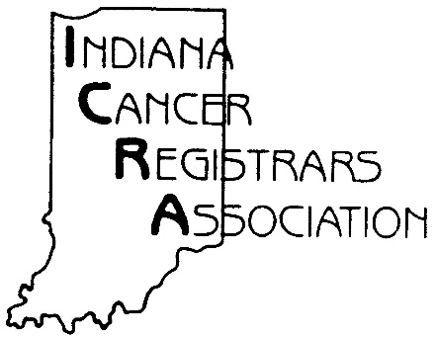

July 16, 2012

Dear ICRA Member:

It is that time again my friends to nominate an ICRA member to receive the very special ICRA Distinguished Member Award.

ICRA is full of special, capable and caring individuals. ICRA members are dedicated and loyal; however, some go above and beyond their commitment to their profession by serving on professional associations and by volunteering in events benefiting cancer patients and their families.

I have chosen two ICRA members who are not currently serving on the ICRA Board of Director. These members will determine the winner after evaluating each nomination and selecting the member who is caring – considerate – dedicated – friendly – helpful – knowledgeable – and possibly works with cancer patients and/or their families.

Although, I believe each one of us is a Distinguished Member let’s acknowledge that one special person and honor “One of Our Own” by nominating one of your colleagues for this special honor.

Previous ICRA Distinguished Award Winners:

1993 – Karol Poyser, CTR
1994 – Patricia O’Leary, RHIT, CTR
1995 – Judi Reininga, CTR
1996 – Joann Schultz, RHIT, CTR
1997 – Anita Butz, CTR
1998 – Kay Herrmann, RHIT, CTR
1999 – Judy Anthrop, CTR
2000 – Jan Duncan, RHIT, CTR
2001 – Sheila Snyder, CTR
2002 – Mindy Burch, CTR
2003 – Jean Edwards, CTR
2004 – Sherry Dowling, CTR
2005 – Paul Rice, RHIT, CTR
2006 – Martha Hill, CTR
2007 – Joyce Wynn, CTR
2008 – Patricia Hettick, CTR
2009 – Membership of ICRA
2010 – Janet Stengel, RHIA, CTR
2011 – Betty Jeffers, RHIA, CTR
2012 -

Once you have reviewed the current membership list and completed the attached nomination form, would you please mail (or email) your nomination form to the following US Mail or Email address on or before September 1, 2012.

Sherry Dowling, CTR
Schneck Medical Center
Cancer Registry
P.O. Box 2349
Seymour, IN 47274
OR Email Form to: icra_indiana@yahoo.com

Thanks for your time and commitment in this very special and important nomination!

Sherry Dowling, CTR
ICRA President
Committee members: Martha Hill, CTR and Danilee Thompson, CTR
“Our Time to Shine”

Attachments:
1.) ICRA Membership List
2.) Distinguished Member Nomination Form
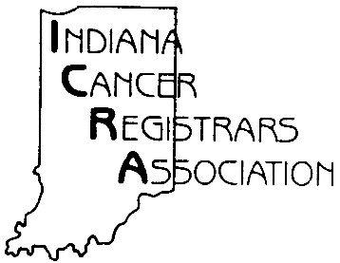
Distinguished Member Nomination Form

Please submit this form by September 1, 2012 to:
Sherry Dowling, CTR
Schneck Medical Center Cancer Registry
P.O. Box 2349, Seymour, IN. 47274
Or Email Form to: icra_indiana@yahoo.com

*******Signature Required*******
Emailed forms will be considered signed

Please consider the following when making your nomination:

Personal Characteristics as evidenced in a least one or more of the following areas:
- Caring – Considerate – Friendly – Helpful - Knowledgeable of the registry profession
Service to Registry Profession as evidenced in a least one or more of the following areas:
- ICRA participation including serving as a Board member, committee chair, task force chair, committee member, and/or task force member.
- Education leadership as evidenced in at least one or more of the following areas: Presenter or co-presenter at local, state, regional or national workshops, meetings, seminars, or conferences.
- Contributor to publications in at least one or more of the following areas: Publication of written material in “The Indiana Abstract,” and/or registry professional articles in state and/or national journals.
- Other contributions to the registry profession in general

Service to Community as evidenced in a least one or more of the following areas
- Work with Cancer Patients and/or families
- American Cancer Society
- Support Groups

I would like to nominate: _____________________________________as the 2012

ICRA Distinguished Member for the following reasons: (additional sheets allowed)

______________________________________________
Your Signature
Appendix G
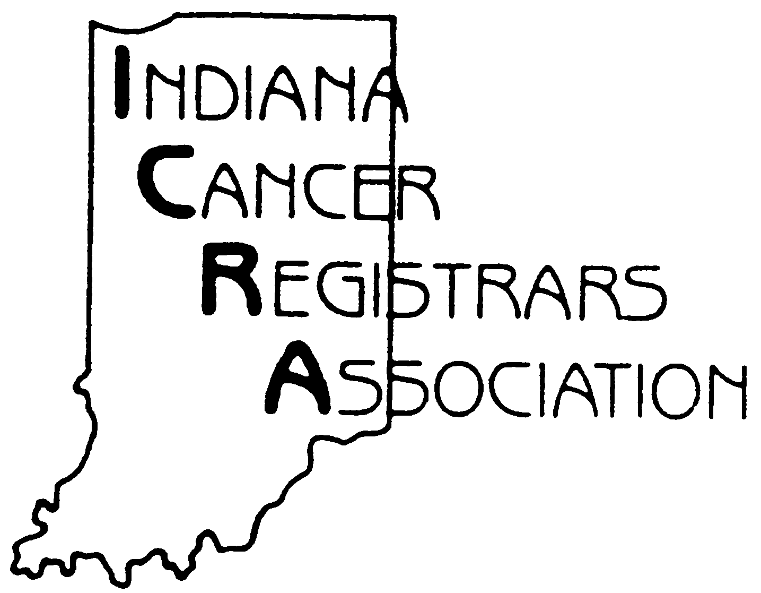

November 2, 2012

Dear ,

It is a pleasure to congratulate you on being nominated to receive the 2012 ICRA Distinguished Member Award.

It is truly an honor to be recognizes by your peers for all the support you give to ICRA, your profession, your employer and your community.

Copies of your nomination are enclosed for your personal use.

Sincerely,

ICRA Distinguished Member Committee

Sherry Dowling, CTR
Martha Hill, CTR
Danilee Thompson, CTR

Appendix H

FOR DEDICATION TO
HER EMPLOYER,
HER COMMUNITY,
HER PROFESSION

BETTY JEFFERS, RHIT, CTR

IS HEREBY PRESENTED
THE

INDIANA
CANCER REGISTRARS
ASSOCIATION

2011
DISTINGUISHED MEMBER
AWARD

Appendix I

FOR DEDICATION
AND ENTHUSIASM TO THE
INDIANA CANCER
REGISTRARS ASSOCIATION

CASSANDRA NOBBE, CTR

IS HEREBY PRESENTED
THE

2011
PRESIDENTIAL AWARD

Appendix J
INDIANA CANCER REGISTRARS ASSOCIATION
2011 Business Meeting Agenda
Report Presentations
Thursday, November 3, 2011
Primo Banquet Center
Plainfield, IN

Call to Order – 2011 ICRA Business Meeting Jan Duncan
Adoption of Agenda Jan Duncan
Quorum of Membership (2/3 present) Judi Reininga
2010 Annual Business Meeting Minutes Cassie Nobbe
Fiscal Year Report Lori Carroll
New Business:
- President’s Message Jan Duncan
- Board of Directors’ Report Presentation
- Executive Committee Reports
President Jan Duncan
President-Elect Sherry Dowling
Past President Camille Foley
Vice President Jan Duncan
Secretary Cassie Nobbe
Treasurer Lori Carroll
- Committee Reports
Audit Committee Sherry Dowling
Bylaws Committee Sherry Dowling
Education Committee Ellen Hurd
Historian Joann Schultz
Membership Committee Judi Reininga
Nominations Committee Camille Foley
Program Committee Nancy Whipple
Public Relations Committee Jan Duncan/Brandy Lewis
Ways and Means Committee Joann Schultz
Cookbook Subcommittee Judi Reininga
Website Committee Cassie Nobbe
- Liaison Reports
American Cancer Society Patsy O’Leary
IHIMA Patsy O’Leary
ISDH Resigned
NCRA Jan Duncan
Commission on Cancer Jan Duncan
- Motion to destroy ballots Camille Foley
- 2011-2012 Elected and Camille Foley and
Appointed Board of Directors Sherry Dowling
- Old Business Jan Duncan
- Meeting Adjournment Jan Duncan
Appendix K

INDIANA CANCER REGISTRARS ASSOCIATION

2011 Recognition and Installation Ceremony Agenda
Friday, November 4, 2011
Primo Banquet Center
Plainfield, IN

- Welcome Jan Duncan

- Recognition of New CTR’s Jan Duncan

- Recognition of 2010-2011 Board of Directors Jan Duncan

- 2011 Distinguished Member Award Jan Duncan

- 2011 President’s Award Jan Duncan

- President’s Farewell Message Jan Duncan

- Installation of 2012 Officers Sherry Dowling/Pat Cockerham

- Passing of the Presidential Gavel Jan Duncan/Sherry Dowling

- 2012 Presidential Message Sherry Dowling

- Conclusion of Ceremony Sherry Dowling

